Automated IR GST Filing
CashManager is proud to be the first accounting software program in New Zealand to release the IR Automated GST filing feature that links directly to IRD on their new gateway.
So now you can View and Finish your GST return, then choose Submit to the IRD, login with your IRD credentials and wait for the confirmation that your GST return has been filed.
To use this service you need to have an IRD Login and if you are an Accountant filing on behalf of your customers you must also have Agent access for your customer.
If your IRD GST Filing does not coincide with your Financial Year End – we recommend that you contact the IRD to have this changed.

Completing Your GST Return
- Choose Reports on the Toolbar  - Choose the GST Return reports  - Choose the return type;  - Non provisional tax payers choose 101A-Standard GST Return  - Provisional tax payers choose the 103 form as per your arrangement with IRD |  |  |  | 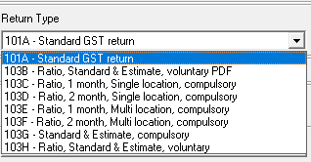
- Select View or Print  - Enter any GST adjustments, and complete information as prompted (this changes based on the Return Type you chose in Step 2)  - If you have chosen a 103 form type you will be prompted for the relevant ratio, standard or estimate information requires to calculate the provision tax payment portion of the return – complete these boxes as they are displayed. |  | 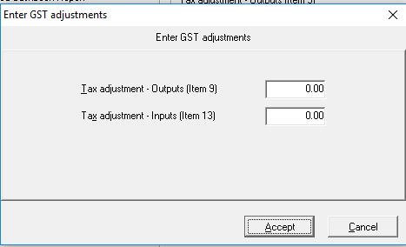
- View the GST return and check the Audit Trail for accuracy. If you need to make any changes close the return and choose ‘No’ to finalise it, make the changes then view or print the report again  - Once you are happy with the return when closing choose ‘Yes’ to finalise the return |  |  |  |  | 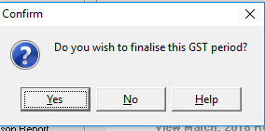
- Choose yes when prompted you are about to finalise this GST period. |  |  | 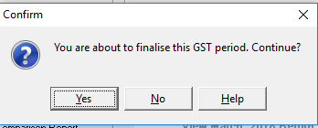

Submitting Your GST Return
- Once your GST return has been completed in CashManager the Submit xxxx, 20xx Return button is enabled in the Report screen (where xxxx, 20xx is the Month and Year that you are finalising) |  |  | 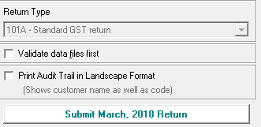
- Choose the ‘Submit xxxx, 20xx Return’ button  - Do not tick ‘This is the final GST return’ unless you are no longer going to be filing any further GST returns for this entity – ever.  - Check that the details in the IRD Authorisation and Lodgement screen are correct and then select the ‘Submit Return to IRD’ button | 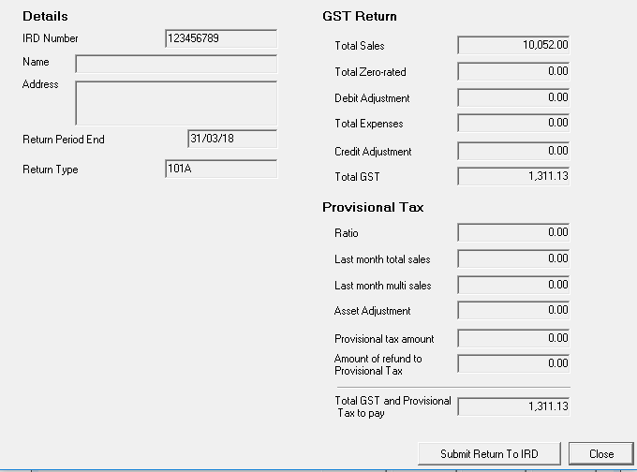
- Enter your IRD login details into the IRD window
You will receive back either;
  - Confirmation that the GST return has been successfully submitted – you can Print the Confirmation Receipt details from this screen
  - An error which will state why the return could not be submitted. Contact our support team if you need clarification of the error returned

Amending Your GST Return (after it has been submitted)
If you find that you have made an error in your GST return you can re-submit your GST return from within CashManager. This involves you having to Reset the GST return so that you can amend it, and then re-submitting it as an amended return.
- Choose Setup, Options on the menu.  - Then choose the GST setup Tab at the bottom of the screen.  - Select the ‘Reset to Amend’ button to un-finalise the return | 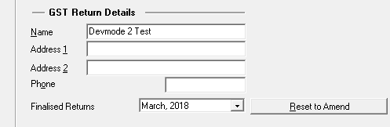
- You can then make the necessary changes to your CashManager data and then go through the process above to re-finalise and re-submit the amended return to IRD

