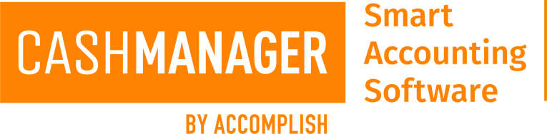

Accomplish Business Partner Programme Options for BookKeepers

- Accredited Bookkeeper:
  - Definition: Accountant or Bookkeeper working as a Bookkeeper who has gone through the Accreditation process.
- Accomplish Accredited Bookkeeper Business Partner Programme Description

Requirements to become an Accomplish Accredited Bookkeeper

- $1,000 incl. GST for the first year, $500 incl. GST per annum thereafter per person to be accredited.
- Pass of Accreditation Examination

As an Accomplish Accredited Bookkeeper you will receive:

- CashManager Standard with Invoicing for in-house use (comes with 3 company entities – more can be added with a one-time cost of $50 per entity)
- Access to our support and client services teams via our special Priority Hotline
- Marketing collateral at no additional cost
- Accredited Logo to use on marketing material (Prior Approval to be given by Accomplish Pty Ltd)
- Training to be completed at least once every twelve months and latest features highlighted within this training.
- At least one member of staff to complete the accreditation examination completed and a pass gained every 12 months
- Discounted pricing
- Credit for all purchases. Please refer to terms and conditions on application form for details on terms of credit.
- Access to 'Accredited Business Partner Only' area of the website, providing access to on-line ordering, CashManager Knowledgebase and various downloads
- Regular Newsletter

